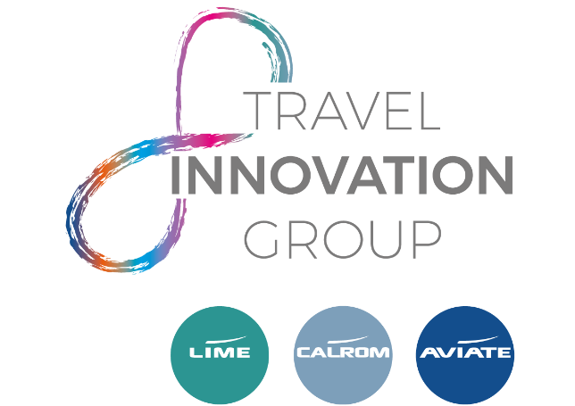

JOB DESCRIPTION

MARKETING EXECUTIVE – AVIATE

JOB PURPOSE: To support the Marketing Manager in providing a professional, efficient and proactive marketing service to all Aviate airlines. To assist in creation, implementation and delivery of core marketing activities to enable Aviate to hit overall marketing and sales objectives. This role is within a busy and expanding marketing team.

RESPONSIBILITY & ROLE:

- Work closely with the Marketing Manager to create campaigns that attract new business, increase brand awareness within the trade to enable an increase in sales across Aviate

- Generate new, creative ideas to enable us to continually improve and evolve Aviate’s marketing

- Monitor the response and conversion rates of all marketing campaigns, produce end of campaign reports and evaluate the results to improve future activity

- Work closely with other departments across all revenue streams to understand what is happening in the market place to help influence future campaigns and to ensure the activity is relevant to the target audience

- Able to balance creative flair with analysis – ability to understand commercial viewpoints, marketing statistics, budgets, Profit and Loss sheets

- Writing and proof-reading copy for multiple channels including; emails, direct mails, blogs, user guides, websites, news feeds and any other ad-hoc requirements

- Work within agreed timelines and meet deadlines

- Have a deep understanding of the Aviate Brand to ensure it is always protected

- Understand each airline, ensuring airline brand guidelines are always adhered to

- Design & implement market research projects as and when required

- Brief projects into the internal design team, ensuring designs meet the overall requirements of the project – being sure to give fair, clear and constructive feedback

- Liaise with external suppliers to secure the best quality and price and deadlines are met

- Plan and manage events/FAM trip projects as and when required

PERSON SPECIFICATION:

- Minimum of 3 years marketing experience
- Competent user of all MS programmes including; Word, Excel and PowerPoint
- Travel/Aviation industry experience is desirable and would be advantageous
- Experience in working with budgets
- Experience in working in a busy role, working on multiple projects at once
- A team player able to work with people at all levels
- A confident innovator & sharer of ideas

