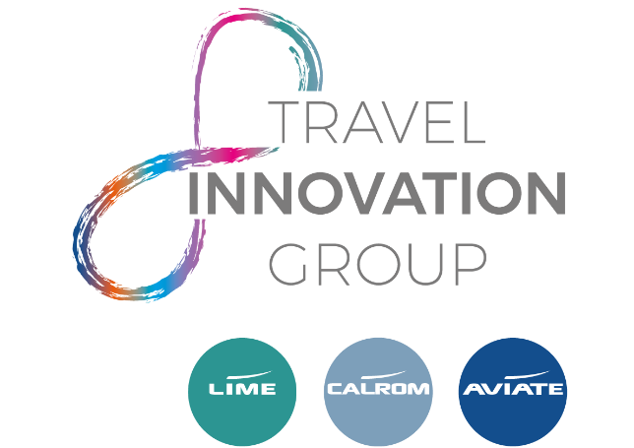

JOB DESCRIPTION

Role: Product Support – Technical Integrations
Reports to: Product Manager – Technical Integrations

The Travel Innovation Group is the parent company for Lime Management, Aviate Management and Calrom. Aviate Management is a specialist flight consolidator representing over 60 major airlines, and Lime is a flight consolidator and service provider for British Airways and the IAG group. Our business is built on automation, and systems which are mainly developed by our own software development company, Calrom.

Our portfolio of innovative products and service solutions aid businesses from travel organisers to airlines, from singular fare services to full business process outsourcing - and plenty in between. This is an exciting opportunity to join a rapidly expanding business for someone who is prepared to throw themselves into the role and wants to see their career grow.

Objectives:
- Work within a travel trade and developer support level 1 help desk, providing quality services for customers.
- Be the first point of contact for these customers when they require any assistance.
- Investigate technical queries and problems, including working with XML and JSON files.
- Investigate fare and pricing related queries.
- Answer any general questions from customers about our technical products.
- Understand customer businesses and how they use our technical products.
- Assist in User Acceptance Testing (UAT) of new functionality, fixes and version upgrades.
- Liaise with system development teams, product owners and other relevant teams.
- Contribute to knowledge base comments and articles to further internal and external knowledge transfer.
- Support our Business Development teams with sales documentation for our technical products.
- Support our in-house support teams with training and documentation for our technical products.
- Assist in day-to-day usability of these projects.
- Provide support and be recognised as a subject matter expert on specified projects.
- Explaining technical jargon to non-technical teams.
- Support the creation of functional specifications for new systems and processes.

Product Portfolio (not an exhaustive list):

- TIG API
- TIG Cache
- Ticketing Robot(s)
- Customer GDS Integrations

General

- Be a committed, enthusiastic, and supportive team member.
- Be aware of company’s goals and aims and strive to achieve at every opportunity.
- Be aware of company and teams’ goals, aims and SLA’s and strive to achieve at every opportunity.
- Deliver an efficient and professional service to customers.
- Attend and contribute in a positive and objective manner at team meetings or any relevant departmental/company meetings.
- Compile accurate business communications and reports as required.
- Acknowledge correspondence within set standards and timescales.
- Assist other departments when and where necessary to ensure business continuity and minimum standard performance.
- Strive to continuously improve the quality (presentation, accuracy, and coverage) of information relevant to the product.
- Aim to “self-learn / develop” skills and understanding of industry practices, procedures and policies that would impact on the team.

